# The theory of IMEI, IMSI and Android

A mobile phone connect to the network by a GSM module. A GSM module can host thousands of mobile phones, and it use two information to recognize the phones from each other is the IMEI and the IMSI number.[1] The system of IMEI numbers was valid from 2003[2]. The IMEI number is a 14 og 16 digits. As seen in the figure, the IMEI number is given, by a set of different digits. The first two digits, marked on the figure with “NN” is the Reporting Body Identifier. The Reporting Body Identifier is a geographic assign code. The next 6 digits, marked with a “XXXXYY” on the figure is the ME Type Identifier. ME stands for Mobile Equipment. Is identifiers which type of mobile phone it is. The “XXXX” is the original identifiers digits. In the beginning, the YY were set to “00” until they were needed. The “ZZZZZZ” on the figure is the digits for the serial number. The serial number is a unique number for every cellphone of a specific ME type. The last digits is a check digit, which is generated by a function of the other digits, and is uses for verifying the IMEI.



The IMEI numbers has been extended by two digits since its first origin.

When the IMEI number is sticks to the cellphone, the IMSI sticks to the SIM-card. The IMSI is similar to IMEI and stands for International Mobile Subscriber Identity. Where the IMEI is like the chassis number of a car, the IMSI is the registrationnumber[3]. The IMSI determents who’s paying for the mobile traffic. The IMSI number is a 14 or 15 digits number, and it is, like the IMEI, generatet by a certain system[4]. As seen on the figure, the IMSI number start with 3 digits, described as “MCC”. The “MCC” stands for Mobile Country Code, and is a specific code, given for which country the SIM-card is issued. The “MNC” is the Nobile Network Code, and is a code, specific for the operator associated with the SIM-card. It can be 2 og 3 digits long. The last 10 digits is the “MSIN” or the Mobile Subscriber Identification Number. Together, these 14 or 15 digits will be the IMSI.

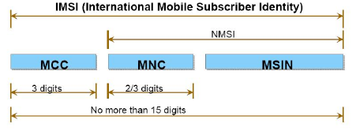

When a cellphone connects the the mobile network, it will send and identify it self with the IMEI and IMSI.

## Android

Android is a OS for smartphones and tablets developed by Google. Google is a multinational company, which make a lot of net based solution like Gmail, Google search, Google Translate etc. Common for all is, that it is free. The core of Android is based on a Linux kernel, with GNU software. The Linux kernel is the core of the system, where the OS GNU software is built on. Android is then a bouilton to the GNU, with the first release in 2008. Several cellphone producents, who uses Android, makes their own skin for Android, like HTC Sense.

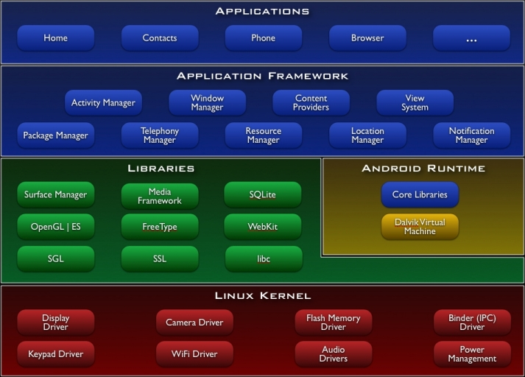[5]

The structure of Android is described in the figure. All the drivers and necessary processes is in the Linus kernel. Then there is a lot of libraries, which the Android runtime use to start up. It is the Android Runtime, which control and coordinate the system, where the libraries is read by the runtime. The kernel is the basic structure, which make the runtime possible to start. Then there is the application framework, and the applications, which make the Apps possible on Android.

1. <http://ewh.ieee.org/r10/bombay/news5/GSM.htm>
2. <http://www.gsmworld.com/documents/DG06_v5.pdf>
3. <http://ieeexplore.ieee.org/stamp/stamp.jsp?arnumber=01292128>
4. A parallel method of 3g firewall
5. <http://developer.android.com/guide/basics/what-is-android.html>